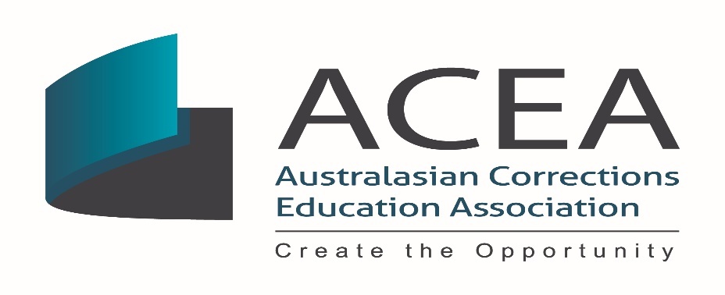

ACEA AGM Meeting Minutes 2019

Date: | Tuesday, 15 October 2019
Time: | 7.30 am – 8.30am AEST
Venue: | RACV Club, Bourke St, Melbourne

Attendees: Ray Chavez, Ron Wilson, Kieran McCann, Paul Barnes, Jane Stapel, Stavroola Andersen, Pirjo Smythe, Abdul Abdullah, Helen Farley, Carol Angove, Ryan Andrijich, Diane Lajos, Geraldine Anderson, Cathy Michelini, Rajesh Koppola, Susan Habib, Charmaine Bazoumi, Chris Mahon, Elissa Simon, Deborah Westfield, Lina Mekaoui, Alex Laragy, Emily Innes, Tim Bowler, Francesca Suffield, Leezette Chopman, Helen Farley, Cameron Tyrell, Nola Skeers, Kim Huett, Mary-Ellen Blackburn, Marietta Martinovic, Greg Wirth, Tony Layh, Adrian Elves, Wayne Chrimes, Karen Wright, Daniel Ritossa, Julie Wasnig, John Corcoran, Angela Hoare- Lippman, Ben Bolkunowicz, Debbie Moon.

Agenda items
A | Ray Chavez declared the meeting open at 7.30am
B | The minutes of the 2018 AGM were reviewed – the names of Kieran McCann and Deborah Westfield to be added to list of attendees.
C | President’s Report  The President’s report has been emailed to all current members.  Ray advised of two ACEA members outstanding achievements.  - An Australian Corrections Medal was presented to the Campus Manager of West Kimberley Regional Prison for outstanding correctional service in developing and facilitating education initiatives for Aboriginal prisoners. The Medal recognised two initiatives; one involved Community Radio, and the other Driver Education. Each initiative helped address an area of concern for regional Aboriginal prisoners returning to their communities. This was the first time the medal has been awarded to a correctional education staff member.  - West Australian Prison Educator, Ange Leech, is the first correctional educator to be awarded a two year Fulbright Scholarship to study in the USA. The scholarship was awarded based on her work in the use of the creative arts, and its potential to assist in prisoner rehabilitation.
D | Treasurer’s Report  Over the last 8 months in the role, Paul has focused on adhering to standards to ensure consistency and transparency. A clear business plan is required to assist with forward planning and to ensure clear and transparent policy and procedures.  In keeping with the Associations Incorporation Act (NSW) 2009 an income and expenditure statement (profit and loss statement) and a balance sheet have been prepared. Total revenue received for the 2018 – 2019 financial year was $9,094.60 received through membership and sponsorships, significantly BSI and Open Universities. Total expenses included Admin, Bank fees, executive travel, website fees and conference fees (trading name of Conference National is Shortlead). Total expenses came to $53,580 leaving a loss of $44,485.40 for the financial year ending 30 June 2019.  Travel expenses for ACEA executive and conference fees were extremely high when offset against extremely low membership and sponsorship revenue.  As the conference is a biennial event, membership and conference fees provide the main income during the conference year however a shortfall has to be managed in the following non-conference year. The Treasurer advised of the need to maintain members gained through the conference and articulate a strong strategy moving forward.  Future conference planning is necessary to deliver a budget surplus to moderate off-conference year losses.  Motions to be put forward and carried:  - ACEA AGM notes the financial loss ($44,485.40) for the financial year ending 30 June 2019.ACEA AGM accepts the 2018 – 2019 Financial Report.  Moved: Ron Wilson Seconded: Paul Barnes  Motion carried  Financial reports have been independently validated by Gregor Tytherleigh CPA. ACEA to develop and implement a strong business plan to offset the gains in the non-conference year and set targets for such.  ACEA to be consistent with the Australian Accounting Standards.  Moved: Ron Wilson Seconded: Kieran McCann  Motion carried  - As ACEA is registered in 2 states, QLD & NSW, registration is to be ceased in Queensland. ACEA reports to NSW and no reports have been forwarded to QLD therefore QLD registration is to be ceased effective immediately.  Moved: Ron Wilson Seconded: Kieran McCann  Motion carried
G | Business  - ACEA Constitution changes  The Constitution requires updating to ensure the following:  - that ACEA rules comply with, and are consistent with current NSW Incorporated Associations Act 2009 and associated legislation and regulations;  - to consolidate recommendations agreed at the 2018 ACEA AGM but not registered within the ACEA constitution; and  - to update ACEA constitutional position on ACEA membership, ACEA Executive membership and terms of appointment, ACEA Advisory Council membership and ensure consistency in terminology throughout the ACEA constitution.  Motions to be put forward and carried:  The following recommendations were submitted for approval:  - That the ACEA definitions clause 1 sub clause update reference to  the current Act as follows from  “The Act means the Associations Incorporation Act 1984  to read  “The Act means the Associations Incorporation Act 2009”  Moved: Ron Wilson Seconded: Paul Barnes  Motion carried  - Cessation of membership clause 4(1) does not mention non- financial members. At present the constitution reads that once a member, they remain so, regardless of their financial status. Under current rules a member can only cease if he/ she: dies, is expelled or resigns.  The recommendation is  That clause 4 (1) be updated to read:  A person or organisation ceases to be a member of ACEA if the person:  (a) Dies; or  (b) Resigns membership; or  (c) Is expelled from ACEA; or  (d) Is non-financial over 3 months post due date  Moved: Ron Wilson Seconded: Paul Barnes  Motion carried  - Current rules read that each executive member is elected until the  biennial conference AGM. i.e. two-year term. Executive members elected out of cycle i.e. at annual AGM are of 1 year term or those nominated at time of vacancy have a term for the balance of that vacancy until biennial conference AGM.A staggered appointment schedule is based on a 2 year term of appointment with the initial appointment of 3 board members to 1 year and the remaining appointed to a two year appointment.  At the next AGM, the 3 one year positions are then appointed to two year terms. This approach allows for a greater continuity of Board member appointment with half board turnover annually.  The recommendation is that clause 14 (3) be updated from:  “Each member of the ACEA Executive committee is, subject to these rules, to hold office until the conclusion of the biennial ACEA conference following the date of the member’s election, but is eligible for re-election.”  to read  “Each member of the ACEA Executive Committee is, subject to these rules, to hold office from the conclusion of the AGM for a two year term following the date of the member’s election. Each member of the ACEA Executive is eligible for re-election to a maximum of 2 two year terms.”  Moved: Ron Wilson Seconded: Helen Farley  Motion carried  Executive officers appointed out of cycle are considered appointments not acting positions.  - ACEA institutes a position of Past President for a one year term in order to maintain continuity at a senior level. Ray will be the first President to occupy this role.  Moved: Ron Wilson Seconded: Helen Farley  Motion carried  - Clause15 (4) incorrectly references rule 22. Needs to change to rule 18. The recommendation is that Clause 15 (4) be re worded to read:  “Any vacant positions remaining on the ACEA Executive Committee are taken to be casual vacancies and may be filled in accordance with rule 18”  Moved: Ron Wilson Seconded: Kieran McCann  Motion carried  - There is inconsistency in the terminology used for the Advisory Council. It has sometimes been referred to as the Advisory Board. The  recommendation is to replace all instances of the use of Advisory Board  with Advisory Council.  Moved: Ron Wilson Seconded: Paul Barnes  Motion carried  - The ACEA Executive (August 2019) agreed NZ representation needs to be formally included in the ACEA Advisory Council under rule 23 (2) the recommendation is that New Zealand representation be included in the listing of state/ territory representatives under Rule 23, clause (2).  Moved: Ron Wilson Seconded: Kieran McCann  Motion carried  - Helen Farley to be formally recognised as the New Zealand Representative on the Advisory Council.  Moved: Ron Wilson Seconded: Kieran McCann  Motion carried  - That ACEA AGM supports the ACEA executive to prepare a position  role for an International representative on the ACEA Executive Committee.  Moved: Ron Wilson Seconded: Paul Barnes  Motion carried  - That ACEA AGM move to institute a Life Membership category to maintain the experience, knowledge and networks of exiting Presidents  Moved: Ron Wilson Seconded: Stavroola Anderson  Motion Carried  Action: ACEA executive will draw up the parameters of all new positions and circulate to members.
G | ii Other Business  No other business arising
E | Election of Office Bearers  Ray Chavez to fill the Past President role.  The following positions were declared vacant:  Research Officer  State and Territory Representative for Victoria  The three nominees for the Research Officer position introduced themselves:  - Ryan Andrijich  - Carole Petchell (Pyrjo Smythe spoke on Carole’s behalf)  - Marietta Martinovic  The two nominees for the State and Territory Representative position in Victoria introduced themselves:  - Carole Petchell (Pyrjo Smythe spoke on Carole’s behalf)  - Kim Huett  A secret ballot was conducted for the two vacant positions and the following Executive members were declared and elected unopposed :  President: Dr Ron Wilson  Past President: Ray Chavez  Vice President: Kieran McCann  Treasurer: Paul Barnes  Secretary: Angela Graham  Juvenile Justice: Stavroola Anderson  Research Officer: Marietta Martinovic
F | Election of State and Territory Representatives  NSW: Rachel Harper  ACT: Mark Bartlett  NT: Cameron Tyrell  Victoria: Kim Huett  WA: Abdul Abdullah  Tasmania: Byron Jenssen  SA: Carl Schneider  QLD: Sylvia Wilson – Kuhbauch  New Zealand: Helen Farley
H | Next AGM  Confirmation that the next AGM will be held to coincide with the 2021 ACEA Conference and that an election of the ACEA Advisory Council (Exec & State reps) will be held at this time.  Ron Wilson declared the meeting closed at 8.40am

