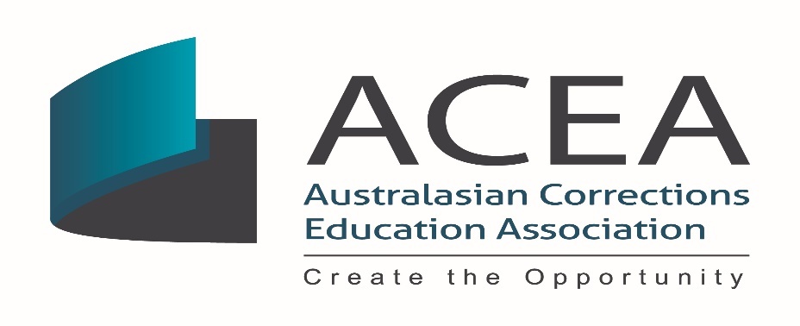

ACEA AGM Treasurer’s Report Financial Year 2019-2020

Date: | Wednesday, 28 October 2020
Time: | 12.00 pm – 1.15 pm AEST
Venue: | Register to access via ZOOM

Statement of Compliance
- As a Tier 2 organisation, it is a requirement of the Associations Incorporation Act 2009 (NSW), that the association’s financial statements are presented to the AGM as an Annual Summary of Affairs.
- In accordance with the legislation and associated regulations, the reports must conform with Australian Accounting Standards (AAS).
- The Annual Summary of Affairs has been prepared for the Financial Year Ending 2019-2020 and includes an income and expenditure statement (profit and loss statement) and a balance sheet.
- The accounts and reports were validated independently by Gregor Tytherleigh CPA.
Points of Consideration
- Australasian Corrections Education Association (ACEA) Inc operated at a net surplus of $46,482.58 for financial year 2019-2020 which when compared with a net loss of -$44,485.40 last financial year is not unexpected.
- The total revenue $180,822.49, exceeded total expenses $134,339.91
- The ACEA account balance at 30 June 2019 was $65,923.66 and is three times the balance last financial year.
- Total revenue was drawn from three streams: membership fees, sponsorships and conference revenue.
- Total expenses were paid into two streams: travel and conference fees.
Issues
- COVID-19 will continue to impact on expected revenue and expenses throughout the financial year and careful consideration needs to be given to the planning for future ACEA activities in a post COVID-19 world.
- There is a need secure ongoing sponsorship and increase the membership base to maintain financial sustainability and viability during uncertain times.
Discussion and Recommendations
- It is expected there will be a steady and sustained growth in membership, sponsorship and conference registrations over the next three years as ACEA transits the online world and that there will be an overall net surplus of approximately $100,000 - $150,000 by 2023.

- The ACEA website has been recently relaunched as a vehicle to engage with members and sponsors and promote awareness of ACEA through online activities. This includes the first webinar presented at this AGM today and our soon to be first entirely Virtual Conference which will be held in 2021.
- Recommendations
- That the ACEA AGM accept the 2019/2020 financial report
- That ACEA AGM notes the financial surplus of $46,482.58 for the financial year of 2019/2020 and its expected growth over the next three years.

